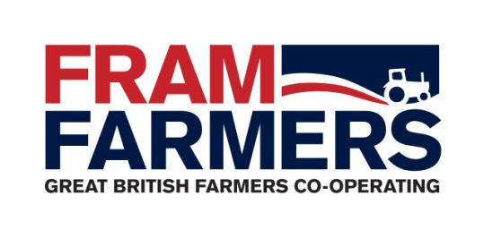

Job Description

Job Title: | Machinery Specialist / GFI Supervisor
Department: | General Farming Inputs (GFI)
Reports To: | GFI Manager
Hours / Days: | Monday to Friday | 9.00 a.m. – 5.30 p.m. | 37.5 hours per week
Job Summary: | Working to the Fram 26 strategy objectives, as part of the GFI team, with specific responsibility for the procurement of Agricultural Machinery / vehicles and related items, including finance on behalf of members at the best possible price and service. Support the GFI Manager with management and development of the GFI team.

Key Responsibilities & Duties

- Commercial Development
- Identify new / alternative commercial opportunities, offering members a unique range of products and services that are not currently provided by the business.
- To participate in the growth of current volumes, turnover and surplus returned to the society.
- Encourage innovative input from members, staff and all other stakeholders.
- Actively develop strategic alliances with existing and new suppliers.
- Create and encourage cross-selling opportunities in the business
- Assist with negotiations with existing and potential suppliers for the most advantageous terms.
- Assist with the development of robust and competitive relationships with key suppliers and have a proactive approach when looking at new machinery products and services.
- Assist with the assessment and investigation of possible new suppliers and products in order to increase / improve service and terms to members.
- Help to Introduce and maintain an element of forward planning to gain commitment and help negotiate more effectively.

- Members
- Work with the GFI Manager on strategic plans for Machinery including measures and milestones.
- Increase member commitment by offering truly unbiased advice.
- Ensure members are kept up to date with developments and new or alternative products as they become available.
- Provide and maintain a high level of service to the membership.
- To add value to Fram membership by designing offers in line with members requirements.
- Work closely with members to ensure offers are fit for purpose.
- Encourage member retention and grow the membership.
- Receive and place member orders daily.
- Attend member engagements as requested, which may require working outside normal working hours.

- Team Supervision
- Monitor and encourage improvements towards standards of work via guidance, coaching and mentoring.
- Recommend training requirements, and further development plans where applicable.
- In the absence of GFI Manager, manage departmental diary including holiday, sickness and general day to day management of the GFI team.
- Support GFI Manager in efficient and harmonious running of the team.

- Administration / Quality Standards
- Maintain accurate records of transactions with suppliers, member orders and supplier meetings.
- Deal with problems and complaints in accordance with standard quality procedures.
- Placing member’s orders on the system and with the correct supplier. Ensure the member ordering process from initial enquiry through to final invoice is carried out in a timely manner.
- Deal with invoice queries as required.
- Submit relevant information for insertion into the FF monthly newsletter and Purchasing News.
- Report achievements and activity to the GFI Manager on a monthly basis.
- Provide support to the fuel and building materials product areas as and when required including holiday / sickness cover and other periods of absence.

- General
- Liaise with work colleagues as required.
- Maintain a professional attitude and promote the group wherever possible.
- Efficient diary management particularly when out of the office or hybrid working
- Participate in internal and external meetings as requested.
- Identify and meet personal job-related training and development as required.
- Undertake telephone liaison with relevant contacts.
- Raise profile of group by attending functions outside of normal working hours.
- Provide assistance in terms of general and specific business support as required.
- Maintain an awareness of the FF Quality System and report any suspicious / suspected breaches of security to the quality Assurance Co-ordinator.

What Qualities Do I need?

- The machinery market is your natural environment; you’ll be familiar with brands, dealerships, products and systems and display a passion to be immersed in and champion this sector
- Your commercial know-how will be sharp and opportunity-focused; the role’s success will hinge on your proactive approach to business: going the extra mile, upselling and highlighting the full portfolio of member benefits and services
- Excellent communication and interpersonal skills go without saying – you’ll display a strong relationship-building ability capable of successfully engaging with farming professionals in order to further develop business
- A good overall standard of IT literacy is required, and you’ll have strong competence in MS Office applications
- You’ll combine excellent team player characteristics (office-trained ideally) with self-motivation and initiative
- You should be in commuting distance to the Framlingham office

Salary / Benefits: negotiable depending on experience
5% non-contributory pension
22 days holiday
Life Assurance
Member Benefits
Hybrid Working

