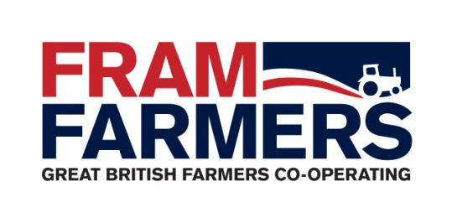

Job Description

Job Title: | Fertiliser Specialist
Department: | Crops
Band | 3
Reports To: | Crops Strategic Partnerships Manager
Hours / Days: | Monday - Friday | 8.30 a.m. – 5.00 p.m. | 37.5 hours per week
Job Summary: | Working to the Fram 26 strategy objectives, with specific responsibility for the procurement of Fertiliser at the best possible price offering the highest levels of service to the membership.

Key Responsibilities and Duties

- Product Portfolio Management
- Promote role as specialist in fertiliser to members, colleagues and supply chain.
- Increase volume and turnover with the existing membership base to meet departmental targets.
- Liaise with Crops Farm Trader in relation to member opportunities.
- Encourage innovative input from members, staff and all other stakeholders.
- Manage seasonal campaigns for fertiliser including the Fertiliser Requirement Form and new season. Defining the process, timelines and resource requirement.
- Actively promote the products and services the group provides to its members to increase share of wallet.
- Liaise with Fertiliser Product Manager on up to date fertiliser prices and terms and communicate to team members.

- Member Service
- Ensure the member ordering process from initial query through to final invoice is carried out in a timely manner.
- Increase member commitment by offering truly unbiased advice.
- Effectively manage dispute resolution in relation to orders of fertiliser products.
- Ensure members are kept up to date with developments via all communication channels including but not limited to video updates, market reports, purchasing news and whatsapp groups.
- Liaise closely with the Member Development team in support of FF’s Member recruitment remit.
- Provide and maintain a high level of service to the membership.
- To add value to Fram membership by designing offers in line with members requirements.
- Work closely with members to ensure offers are fit for purpose.
- Encourage member retention and grow the membership.
- Create and encourage cross-selling opportunities in the business.
- Participate in the development and delivery of Fram events including trials days, regional updates.

- Administration
- Provide support to the administrative personnel in relation to receiving and placing member orders on a daily basis as and when required.
- Maintain accurate records of transactions with suppliers, member orders and supplier meetings.
- Maintain real time accuracy of Fertiliser pricelists
- Ensure annual calendar overview of product portfolio, key events and market details are kept up to date.

- Professional Qualifications / Quality Standards
- Establish and maintain any specific industry qualifications
- Comply with TASCC and FIAS standards, company procedures; ensure any breaches in security are reported to the Quality Co-ordinator.
- Deal with problems and complaints in accordance with the corrective action and customer complaints procedure as set out in the Fram Farmers quality manual.
- Abide by the relevant FACTS / BASIS codes of practice.

- General
- Liaise with work colleagues as required.
- Provide support to the crop protection and seed product areas as and when required.
- Maintain a professional attitude and promote the group wherever possible.
- Collate relevant information on various markets and utilise this information to the groups benefit.
- Participate in internal and external meetings as requested.
- Efficient diary management particularly when out of the office or hybrid working
- Identify and meet personal job-related training and development as required.
- Undertake telephone liaison with relevant contacts.
- Raise profile of group by attending functions outside of normal working hours.
- Provide assistance in terms of general and specific business support as required.
- Maintain an awareness of the FF Quality System and report any suspicious / suspected breaches of security to the quality Assurance Co-ordinator.

